# Assignment 2.2 – **Heatmap, Spatial plot, and Contour plot**

## Tableau

### Heatmap

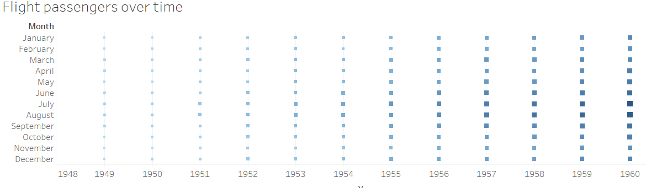

### Spatial Plot

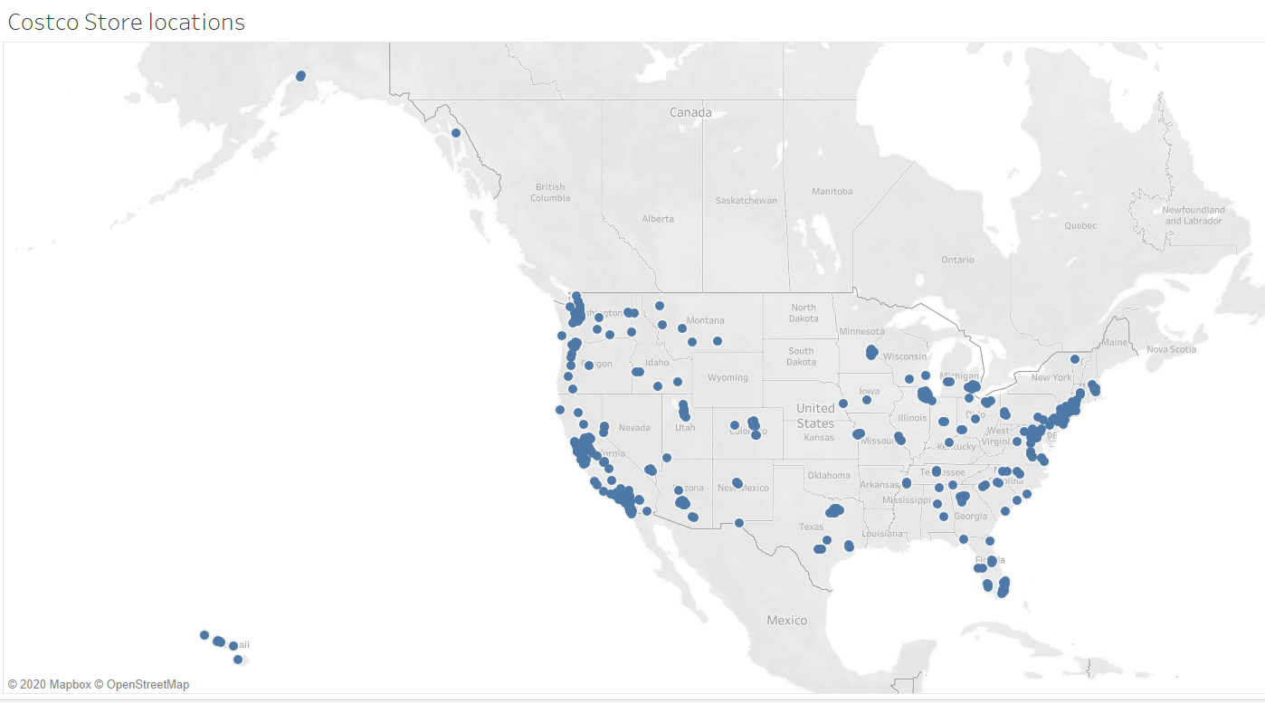

### Contour plot

I couldn’t draw Contour plot in Tableau. I tried several times with different datasets but I couldn’t get it. There is no clear way of doing it and the help on internet is limited too.

## Python

### Heat map

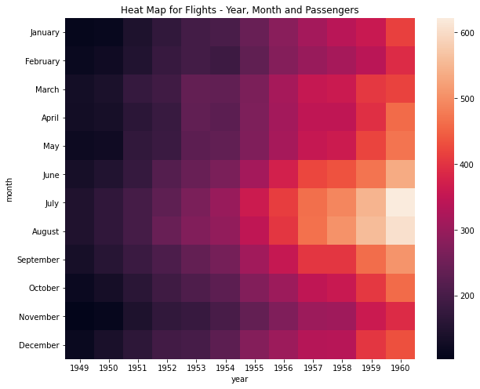

### Spatial plot

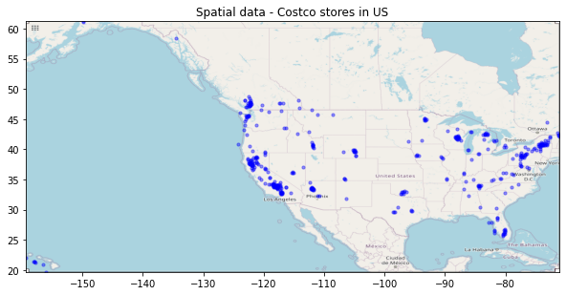

### Contour plot

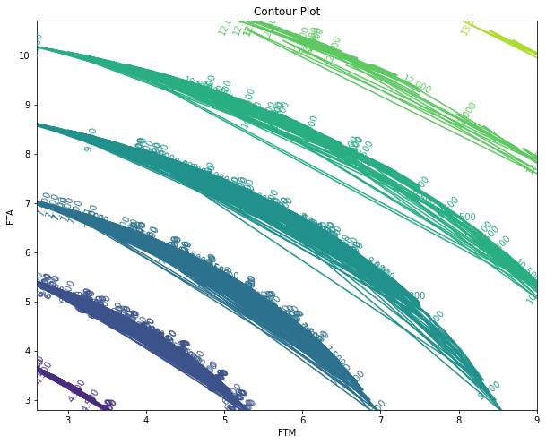

## R Programming

### Heat map

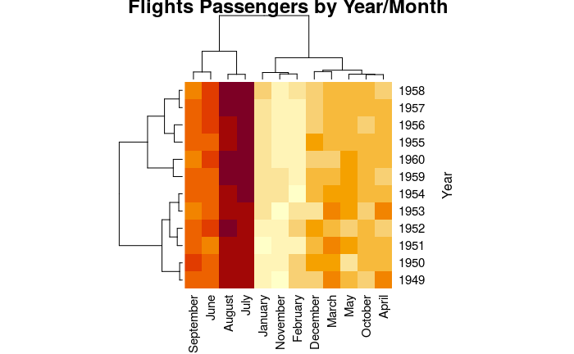

### Spatial plot

Costco Store locations

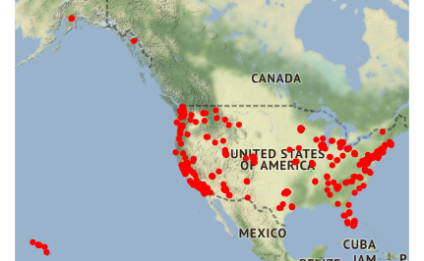

### Contour plot

